**DAILY ONLINE ACTIVITIES SUMMARY**

|  |  |  |  |  |  |  |  |  |
| --- | --- | --- | --- | --- | --- | --- | --- | --- |
| **Date:** | **29th may,2020** | | | | | **Name:** | **Prathusha K A** | |
| **Sem & Sec** | **4th sem &b section** | | | | | **USN:** | **4AL18CS061** | |
| **Online Test Summary** | | | | | | | | |
| **Subject** | | **Operating Systems.** | | | | | | |
| **Max. Marks** | | **30** | | **Score** | | | **28** | |
| **Certification Course Summary** | | | | | | | | |
| **Course** | **Programming for everybody (getting started with python)** | | | | | | | |
| **Certificate Provider** | | | **Coursera** | | **Duration** | | | **7 weeks** |
| **Coding Challenges** | | | | | | | | |
| **Problem Statement:** Write a Java program to Find size of the largest â€˜+â€™ formed by all ones in a binary matrix. | | | | | | | | |
| **Status: done** | | | | | | | | |
| **Uploaded the report in Github** | | | | | **yes** | | | |
| **If yes Repository name** | | | | | **https://github.com/prathu47/lockdown-coding** | | | |
| **Uploaded the report in slack** | | | | | **yes** | | | |

Online Test Details: (Attach the snapshot and briefly write the report for the same)

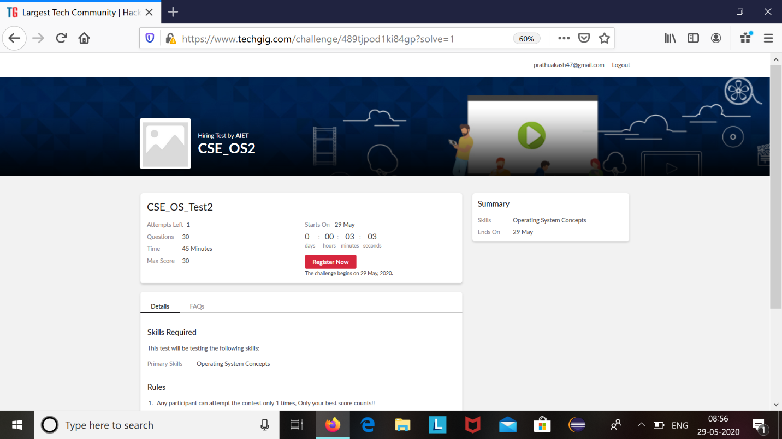

Operating systems internals was conducted today. A total of 30 questions which is of mcq. Started at 9:00 AM and ended at 9:45 each carries one mark. It is on the topic of operating systems concepts.

The above snapshot is the result sheet which was sent to us by the Techgig team.

Certification Course Details: (Attach the snapshot and briefly write the report for the same)



The course I have chosen during the lockdown period is programming for everybody. Since I had previously knew few topics about python iam continuing this course. Since python is gaining a lot of interest in coding platform I have preferred to choose this course.

Coding Challenges Details: (Attach the snapshot and briefly write the report for the same)

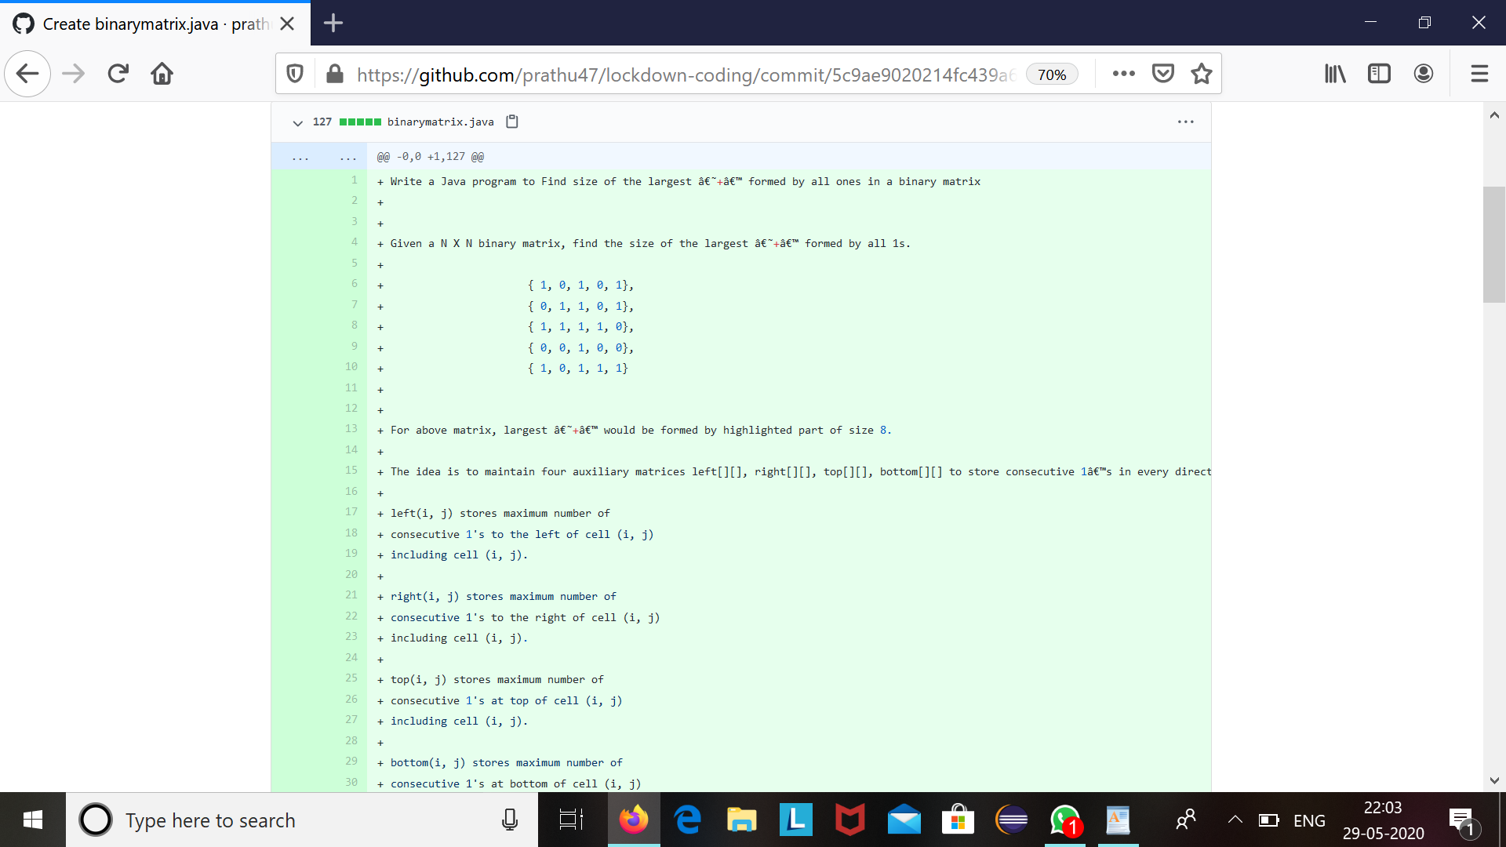

The question we had received today was :

Write a Java program to Find size of the largest â€˜+â€™ formed by all ones in a binary matrix

Given a N X N binary matrix, find the size of the largest â€˜+â€™ formed by all 1s.

{ 1, 0, 1, 0, 1},

{ 0, 1, 1, 0, 1},

{ 1, 1, 1, 1, 0},

{ 0, 0, 1, 0, 0},

{ 1, 0, 1, 1, 1}

For above matrix, largest â€˜+â€™ would be formed by highlighted part of size 8.

Code:The above snapshot is the code which I have uploaded in my github repository.